CALL FOR ABSTRACTS FOR

The eight student philology conference
„Како си ми?“
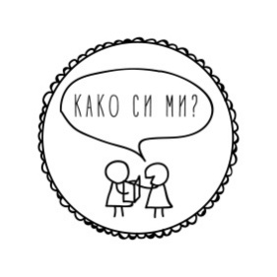

WHEN: 7th of May 2022 (Saturday)

WHERE: live, on the faculty campus, with an option for those who cannot travel from abroad to present on the online platform ZOOM

FOR: First and second cycle students at any faculty and university in the Republic of North Macedonia and abroad, as well as for already graduated/masters students in the current 2020/2021 academic year, foreign students

FORMAT: Individual or group presentation with a time limit of 10 minutes

THEMES: From philology, linguistics, literature, culture, methodology, philosophy, translation and interpretation; as well as comparative, intermediate and interdisciplinary topics
LANGUAGE
IN WORK: macedonian and english language

APPLICATION
DEADLINE: 20th of April 2022 at 10 am

APPLICATION
METHOD: Sending the personal data of all participants: name, surname, cycle and year of studies, department, faculty, university, contact email address; topic of presentation, language of presentation and abstract (from 150 to 200 words) at kakosimi.flf@gmail.com in an attached document of the type "Microsoft Word Document (.docx)"

NOTICE OF
ACCEPTED
APSTRACTS: 25th of April 2022

DEADLINE FOR
SENDING
TEXTS: 1st of October 2022

CONTACT: kakosimi.flf@gmail.com
facebook.com/kakosimi.flf
kakosimi.wordpress.com
https://www.instagram.com/kakosimi.flf/

IMPORTANT: All the costs for travel and accomodation fell on the candidates. An exception can be made regarding accomodation in Skopje, but because of the limited number of free places, you have to inform us in your application. Each case will be decided individually.

„Како си ми?“ is a philology conference organised by students at the Philolgy Faculty “Blaze Koneski” in Skopje.
The idea of ​​this conference is to stimulate students' interest in research work, public presentation and discussion of topics that interest them during their studies. With this event students are given the opportunity to talk about their academic interests in front of colleagues, professors and interested philology fans. The initiative that was born as an idea in February 2015, has grown into a traditional event in which students, not only from the Faculty of Philology, but also from other faculties in the country and abroad participate. After the presentations, interesting discussions are always developed on current topics from all fields of philology.
The organizing team of the conference works voluntarily and tries to organize accompanying activities, lectures, workshops and informal gatherings.

